**LAB DAY-1**

**Exercise-1:**

**Program:(Addition)**

num1=as.integer(readline(prompt = "Enter the num 1:"))

num2 =as.integer(readline(prompt = "Enter a number2:"))

sum=num1+num2

print((paste("sum:",sum)))

**Output:**

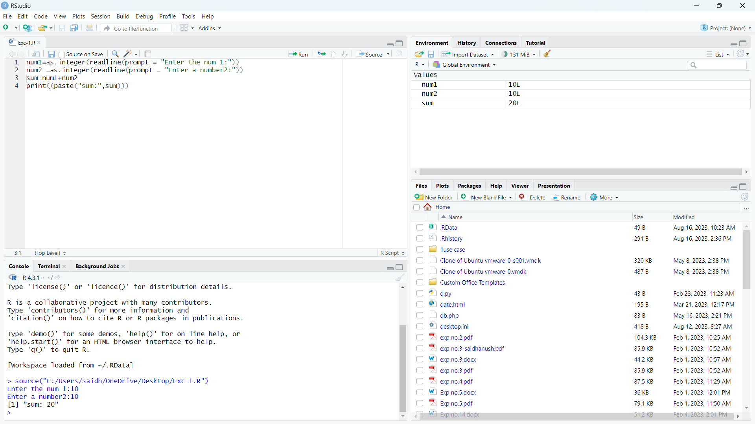

**Exercise-2:**

**Program:(Mean)**

height <-c(150,174, 138, 186, 128, 136, 171, 163, 152, 131)

result.mean <-mean(height)

print(result.mean

**Output:**

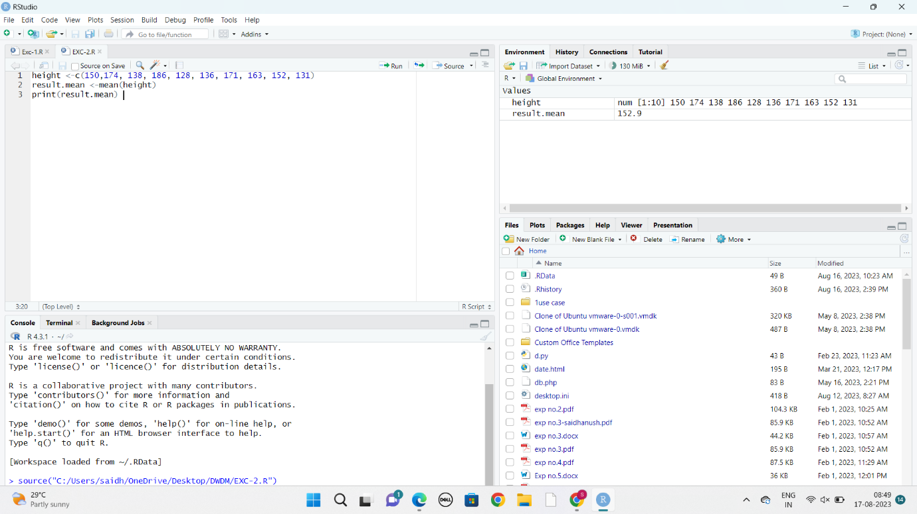

**Exercise-3:**

**Program:(Bar plot)**

temperatures <- c(20, 22, 25, 29, 23, 27, 28)

result <- barplot(temperatures,

main = "Maximum Temperatures in a Week",

xlab = "Degree Celsius",

ylab = "Day",

names.arg = c("Sun", "Mon", "Tue", "Wed", "Thu", "Fri", "Sat"),

col = "blue",

)

Print(result)

**Output:**

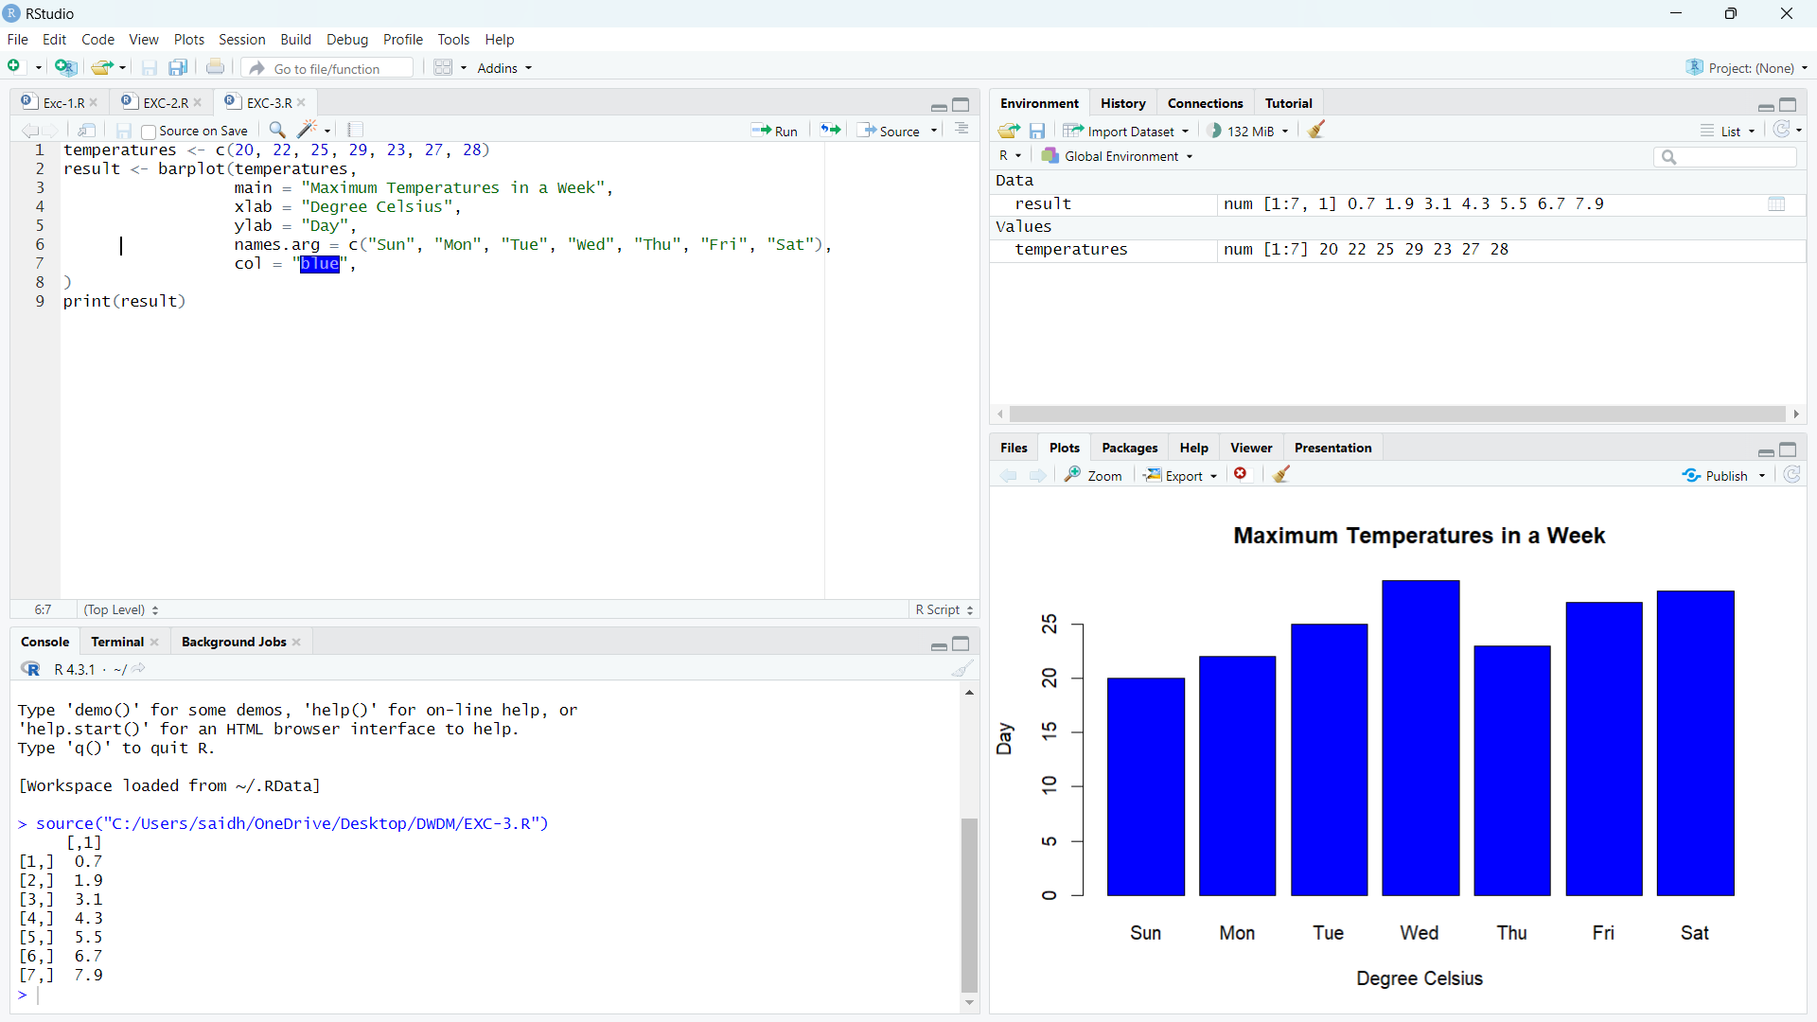

**Exercise-4:**

**Program:(Box plot)**

b <- c(10,12,13,14,17,19,20,30,50,70,90,100)

print(boxplot(b,col="green"))

**Output:**

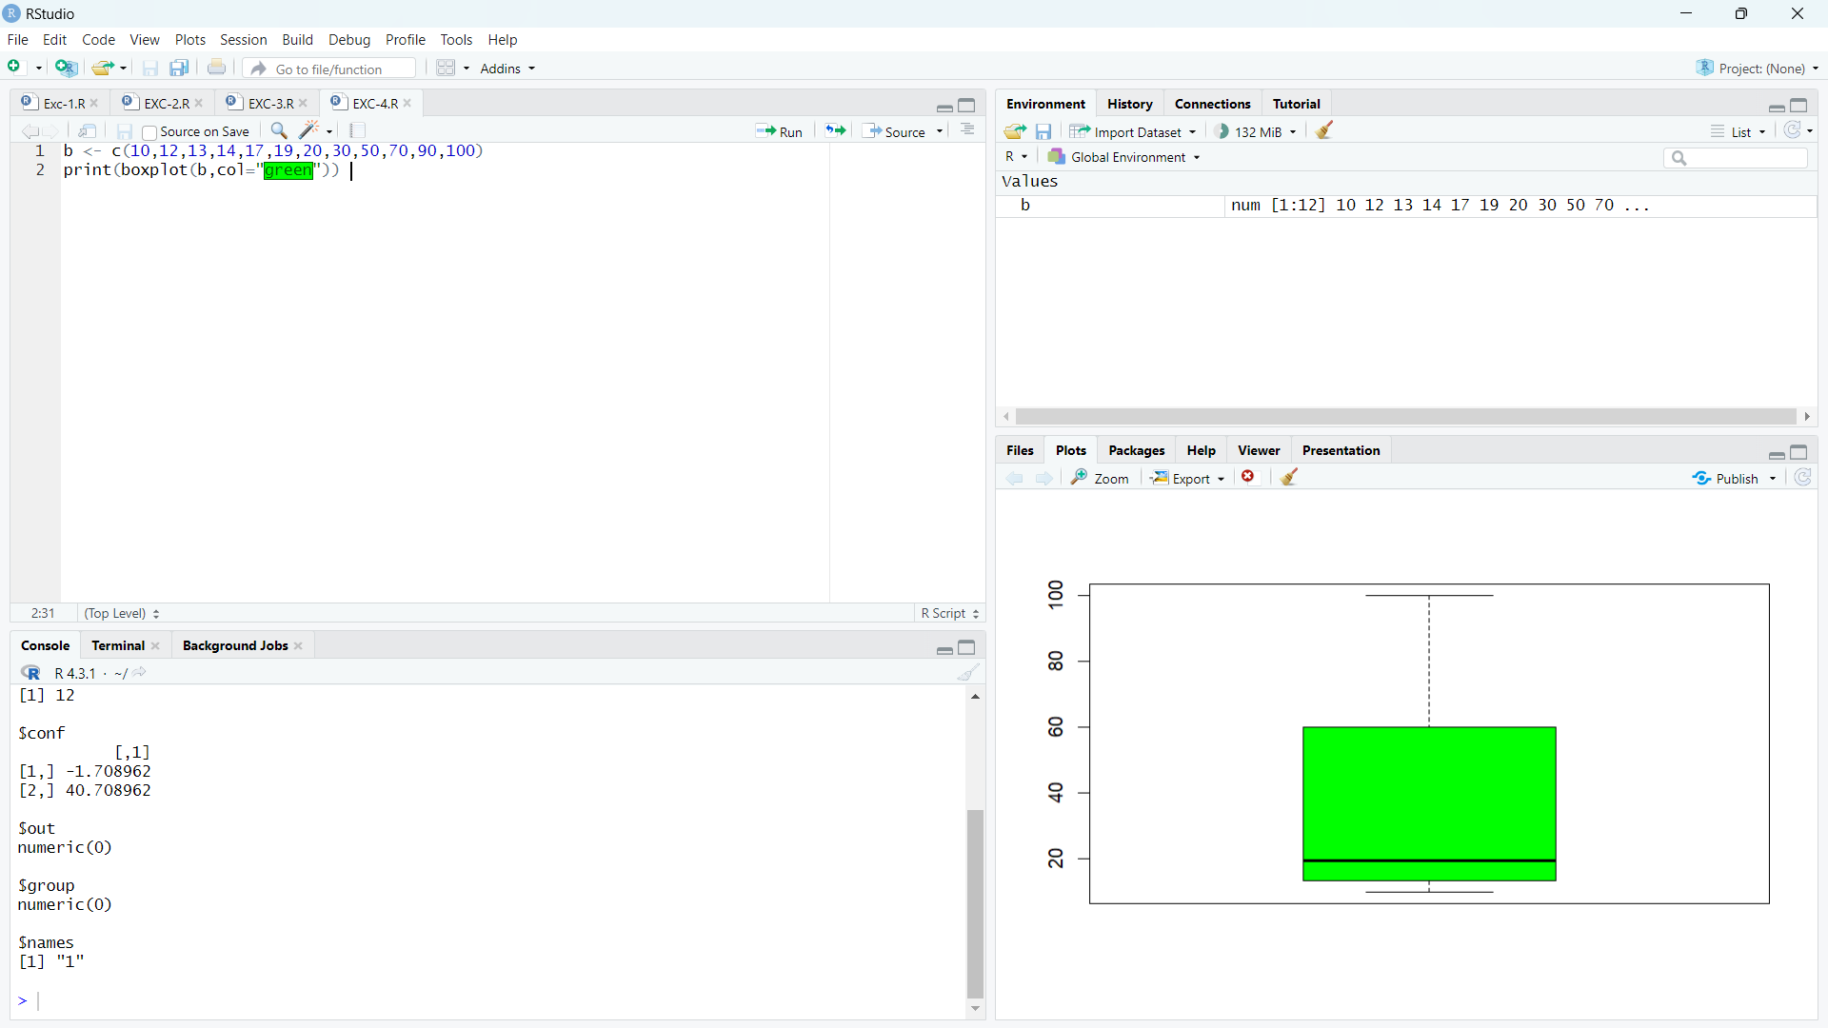

**Exercise-5:**

**Program:(Decision tree):**

library(rpart)

library(rpart.plot)

data=read.csv("C:\\Users\\arunk\\OneDrive\\Desktop\\DWDM\\Gender.csv")

tree <- rpart(Height ~ Gender+Weight,data)

a <- data.frame(Gender=c("Male"),Weight=c(85))

result <- predict(tree,a)

print(result)

rpart.plot(tree)

tree1 <- rpart(Gender~ Height+Weight,data)

a <- data.frame(Height=c(170),Weight=c(85))

result <- predict(tree,a)

print(result)

rpart.plot(tree1)